Guardian of Earth

Jacob Mahoney

Owner

Vision Statement

For Android smartphone users of all ages who want a fun, quick-performing, and re-playable game, Guardian of Earth is an Android application that takes the formula of a basic spaceship shooter and adds depth to the objective of the game. Unlike many other spaceship shooters, Guardian of Earth possesses a unique simplistic art style making it an application that is not only visually satisfying, but is quick to pick and play.

Requirements

**Actors**

**Users** – Motivated users of the app with sufficient enough knowledge to get the app open, and learn about the game through the tutorial to the main menu.

**Actor-Goal List**

|  |  |
| --- | --- |
| Actor | Goal |
| User | Navigates easily through main menu |
|  | Play the game |
|  | Control spaceship rotation with buttons in lower portion of screen |
|  | Control spaceship laser firing with button in lower portion of screen |
|  | Pause the game |
|  | Press the pause button in upper portion of screen |
|  | Resume the game |
|  | Press the resume button that appears after user has paused game |
|  | Change layout and size of user controls |
|  | Go into settings portion of app to modify settings to user’s liking |

**Product Backlog**

|  |  |  |  |  |
| --- | --- | --- | --- | --- |
| Story ID | Story | Story Points | Priority | Status |
| S1 | Allow user to navigate easily through main menu | 3 | 2 | Completed |
| S2 | Allow user to visualize a loading screen that appears momentarily before the game is loaded | 2 | 1 | Completed |
| S3 | Allow user to pause the game while in the middle of playing it by selecting the pause button on the game HUD | 2 | 9 | Not completed |
| S4 | Allow user to resume the game after they have paused by selecting the play button | 2 | 10 | Not completed |
| S5 | Allow user to modify settings like user controls to their liking in a separate settings screen navigated to from the main menu | 3 | 12 | Not completed |
| S6 | Allow user save high scores | 4 | 13 | Not completed |
| S7 | Allow user to, while playing game, to interact with the spaceship’s rotation by clicking buttons | 7 | 3 | Completed |
| S8 | Allow user to, while playing game, to shoot lasers out of the spaceship by clicking another button on the screen | 8 | 5 | Completed |
| S9 | Allow user to, while playing the game, visualize a HUD (heads-up display) including, for example: scores, lives left, pause/play, etc. | 5 | 8 | Not completed |
| S10 | Allow user to, while playing the game, have their lasers interact and collide with asteroids falling towards the earth to score them points | 12 | 4 | Not completed |
| S11 | Allow user to, while playing the game, to also be able to visualize non-interactive game elements like the earth which lies at the bottom of the screen | 6 | 7 | Not completed |
| S12 | Allow user to, while playing the game, to progress through a set amount of waves and each wave gets progressively harder | 8 | 6 | Not completed |
| S13 | Allow user to, when they play the game for the first time, to walk through a tutorial which shows them how to operate the spaceship in rotation and firing, and how to interact with certain HUD elements | 4 | 11 | Not completed |

Sprint #1

**Sprint Backlog**

|  |  |  |  |
| --- | --- | --- | --- |
| Story ID | Story / Task | Estimated Hours | Actual Hours |
| S2 | Setup android studio project and startup activities | 1 | 3 |
|  | Determine if game needs loading screen to show during the loading of game assets | 1 | 1 |
| S1 | Design main menu ui | 1 | 0.5 |
|  | Code main menu ui | 2 | 2 |
|  | Test main menu ui and app startup | 2 | 1 |
| S7 | Determine best algorithm for game loop | 1 | 2 |
|  | Code game loop | 2 | 3 |
|  | Test game loop with placeholder animations | 2 | 5 |

**Retrospective**

I thought my first iteration under the agile methodology went pretty well. I planned to do several tasks for story 1 and story 2. What could have gone better though, was in the beginning of the iteration, I definitely underestimated the learning curve of developing an android app, and simply using Android Studio. So I plan to, in the future, take that into account when planning out my tasks for an upcoming sprint. I also experienced some difficulty in testing game loop, which resulted in an essential complexity rather than an accidental one. That is because, testing the game loop is inherent to the problem, because I don’t have all the game elements in place to test the game loop. So I guess, what I didn’t realize off the bat, is that I will need to test the game loop as I continue to add game elements to the scene to maintain a good performance for the game. So in the future, I will try to plan out and notice those essential complexities beforehand so I don’t waste time on trying to solve something that can’t be solved yet. Overall, I feel the sprint went pretty well.

**Project Velocity**

The project velocity after this sprint is 5 because I completed story 1 and story 2.

**Review**



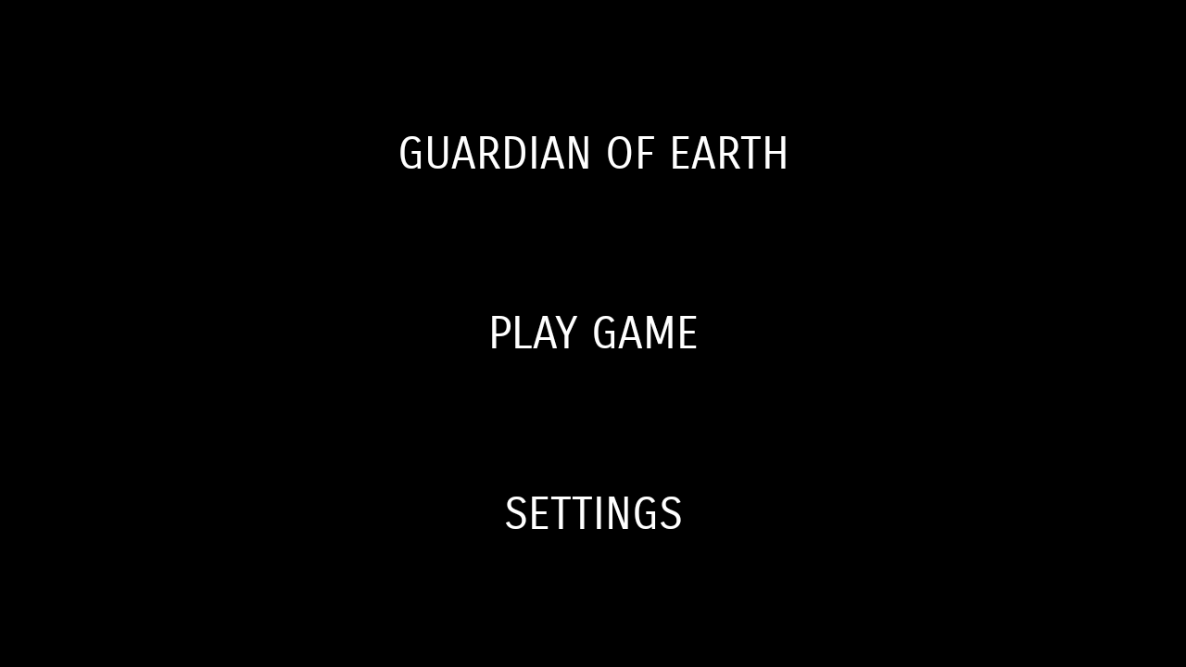

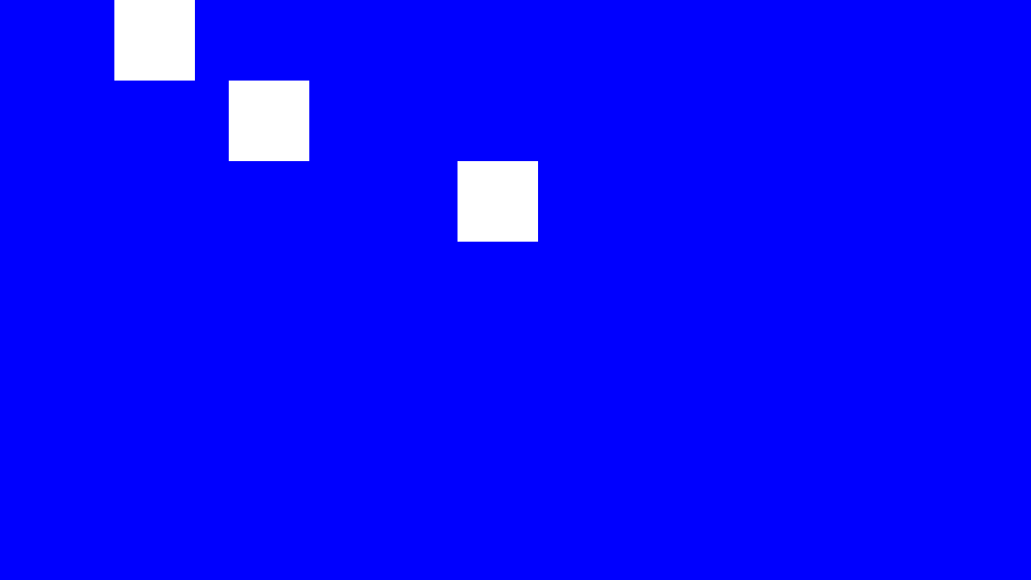

Sprint #2

**Sprint Backlog**

|  |  |  |  |
| --- | --- | --- | --- |
| Story ID | Story / Task | Estimated Hours | Actual Hours |
| S7 | Put placeholder objects into game scene: spaceship, earth, buttons for rotating, button for firing | 4 | 2 |
|  | Add more definition to game object interface | 2 | 1 |
|  | Capture button touches for rotating spaceship | 3 | 4 |
|  | Rig up buttons to rotate the spaceship when they are tapped | 4 | 5 |

**Retrospective**

My second iteration, went pretty well. I did encounter some bugs though, which did slow me down a bit in the beginning. Specifically, dealing with the game loop itself, I spotted a bug that I should’ve noticed sooner, but I didn’t. The bug was that my game loop drastically slowed down as time went on. After many, many hours of searching online for solutions, and eventually asking for help from an online programming community, I found the source of my bug myself. It was a few lines missing from each GameObject’s update function. The main problem with this past iteration was that, even with that main bug that slowed me down a bunch, I feel I still didn’t accomplish much from this past iteration. Because after I squashed the bug that caused extreme lag with my game, the development for rigging user presses to rotate the spaceship turned out to be quite easy. I guess it’s just because I haven’t had much experience at all developing Android apps, and specifically developing a game before, that I don’t know exactly how much to plan to code for each iteration.

**Project Velocity**

The project velocity after this sprint is 7 because I completed story 7.

**Review**

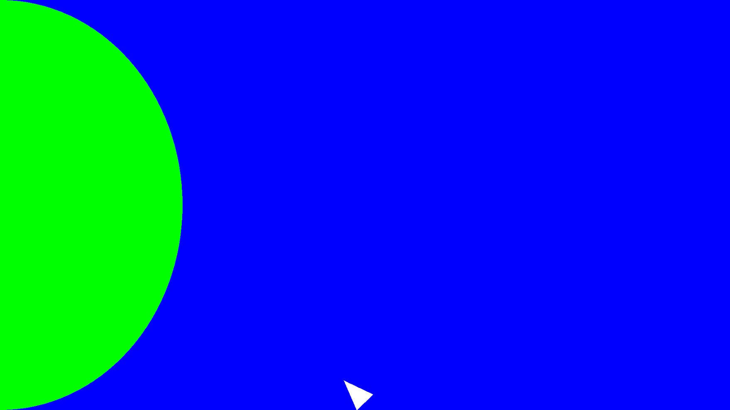

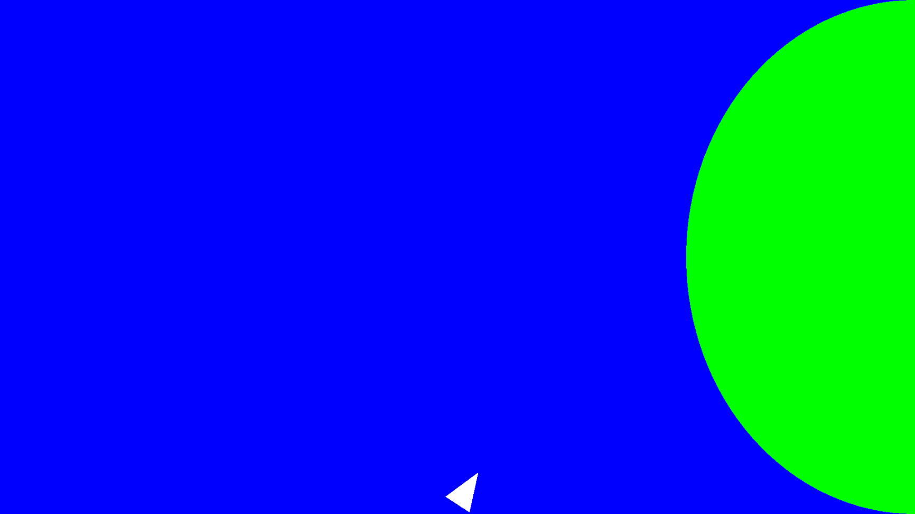

Sprint #3

**Sprint Backlog**

|  |  |  |  |
| --- | --- | --- | --- |
| Story ID | Story / Task | Estimated Hours | Actual Hours |
| S8 | Add button for firing lasers from spaceship | 2 | 3 |
|  | Capture button press for firing lasers out of spaceship | 4 | 2 |
|  | Create a laser emitter class which will handle spawning of multiple lasers | 8 | 12 |
|  | Rig the fire button up to the laser emitter class which will spawn lasers from the end of the spaceship | 4 | 4 |
| S10 | Create structure class for handling the meteors for each wave | 2 | 2 |

**Retrospective**

This sprint was definitely a roller coaster. I went from thinking I wasn’t going to complete the things I had planned out in the spring backlog, to even adding another task to do from a different story because I had a little extra time. The specific task I got held up on was making the function to determine the new nose position of the spaceship after it had been rotated a bit on the canvas. I had to figure out this new position, because that was where the lasers of the spaceship would spawn when the user wished to fire. As I finally finished up, and figured out how to do that I began thinking about the overall structure, design, and layout of the app and how I could use abstract classes to perform similar things. This is what led me to create a ParticleEmitter class which handles the movement of all particles on the screen, whether they are spaceship lasers, or in the near future, asteroids. It also led me to create a whole new wrapper class called, GameHolder, name pending, which will handle all the game objects; functions the game performs, such as firing spaceship lasers; and game constants, such as the different values I will need stored for each wave of the game.

**Project Velocity**

The project velocity after this sprint is 8 because I completed story 8.

**Review**

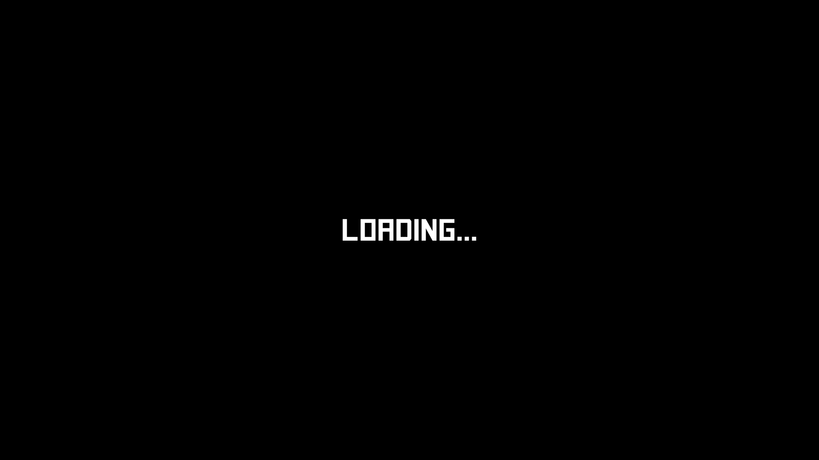

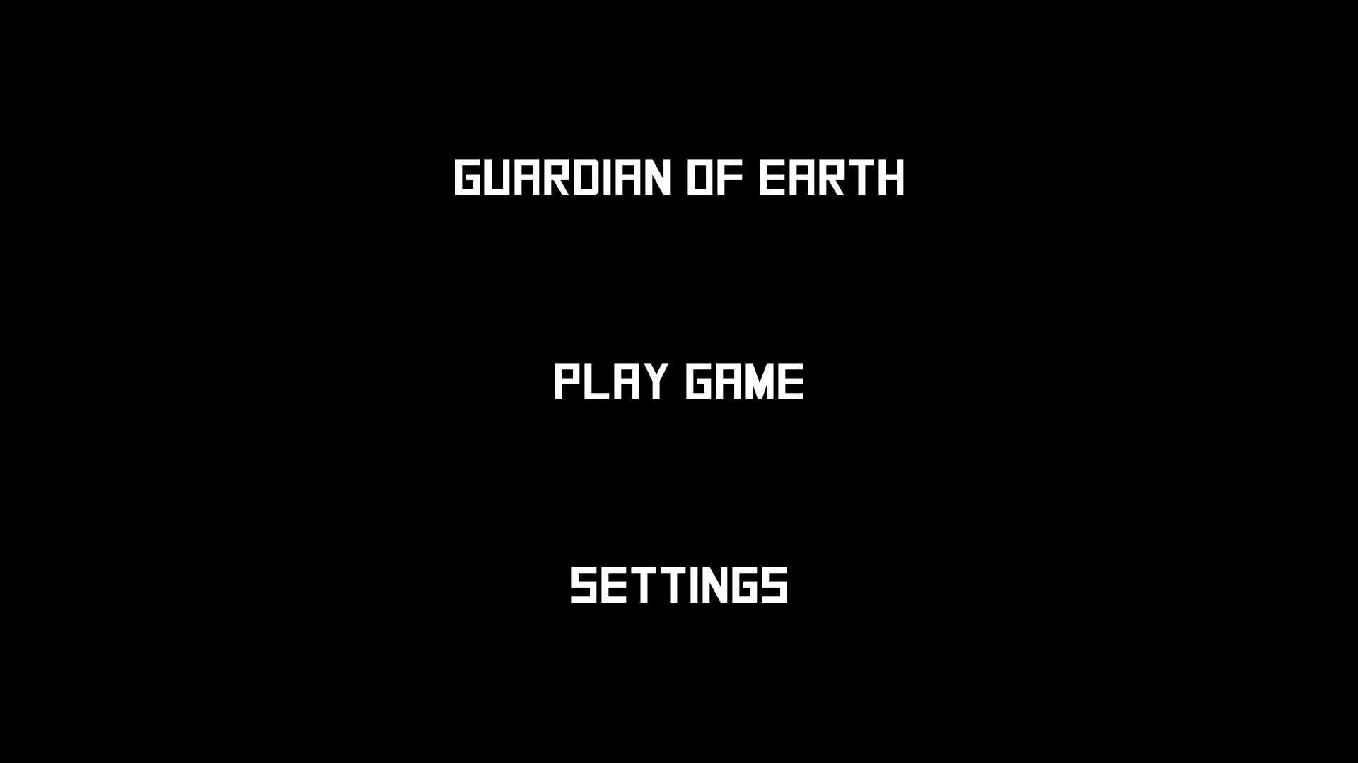

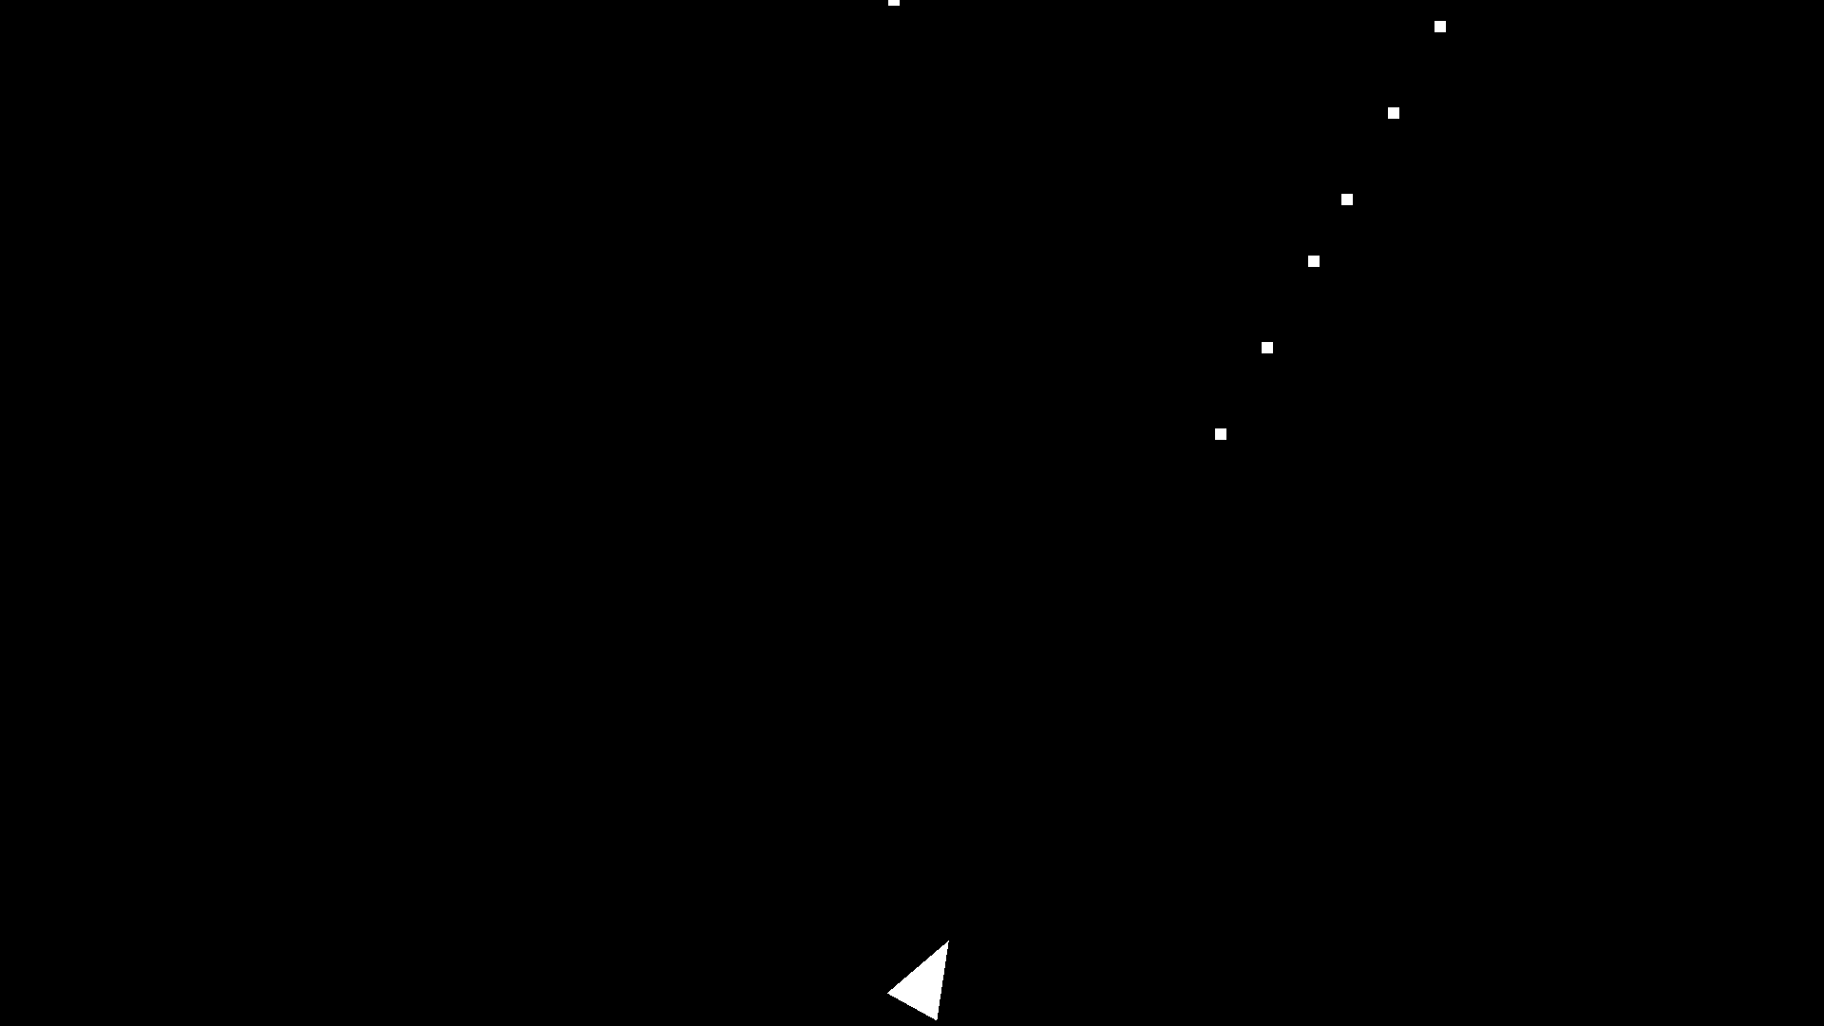

Sprint #4

**Sprint Backlog**

|  |  |  |  |
| --- | --- | --- | --- |
| Story ID | Story / Task | Estimated Hours | Actual Hours |
| S10 | Finish class for handling the meteors that will take in parameters to specify the rate, speed, and number of meteors | 8 |  |
|  | Somehow pass a signal or event back to the parent class from the MeteorContainer class which signals the end of a wave | 10 |  |
|  | Make function for determining collisions between spaceship lasers and the meteors | 6 |  |
|  | Test MeteorContainer using different parameters acting as the different waves the game will progress through | 8 |  |